**PIZZA SALES SQL QUERIES**

1. **Total Revenue:**

**SELECT SUM(total_price) AS Total_Revenue from pizza_sales;**

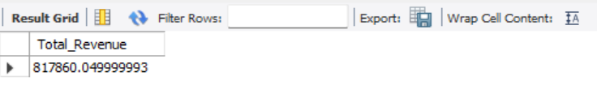

**2. Average Order Value**

SELECT (SUM(total_price) / COUNT(DISTINCT order_id)) AS Avg_order_Value FROM pizza_sales

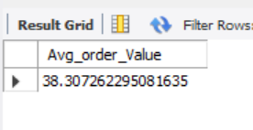

**3. Total Pizzas Sold**

SELECT SUM(quantity) AS Total_pizza_sold FROM pizza_sales

**4. Total Orders**

SELECT COUNT(DISTINCT order_id) AS Total_Orders FROM pizza_sales

**5. Average Pizzas Per Order**

SELECT SUM(quantity)/COUNT(DISTINCT order_id) AS Avg_Pizzas_per_order

FROM pizza_sales

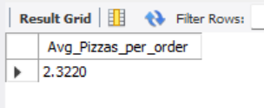

**B. Daily Trend for Total Orders**SELECT DAYNAME(OrderDate) AS Order_Day,COUNT(DISTINCT order_id) AS Total_orders

FROM pizza_sales

GROUP BY DAYNAME(OrderDate) ORDER BY Total_orders DESC

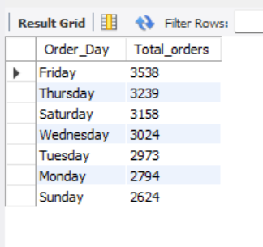

**C. Monthly Trend for Orders**

SELECT MONTHNAME(OrderDate) AS Order_Month,COUNT(DISTINCT order_id) AS Total_orders

FROM pizza_sales

GROUP BY MONTHNAME(OrderDate) ORDER BY Total_Orders DESC

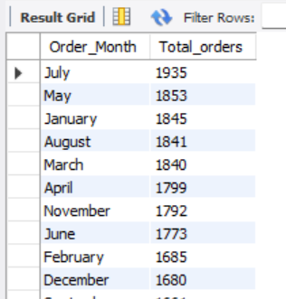

**D. % of Sales by Pizza Category**

**SELECT pizza_category, SUM(total_price) as Total_Sales, (SUM(total_price)*100/(SELECT SUM(total_price) FROM pizza_sales)) AS Percentage_of_Total_Sales**

**FROM pizza_sales**

**GROUP BY pizza_category**

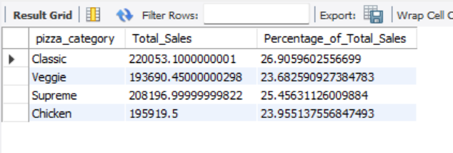

**E. % of Sales by Pizza Size**

SELECT pizza_size, SUM(total_price) as Total_Sales, (SUM(total_price)*100/(SELECT SUM(total_price) FROM pizza_sales)) AS Percentage_of_Total_Sales

FROM pizza_sales

GROUP BY pizza_size ORDER BY Percentage_of_Total_Sales DESC

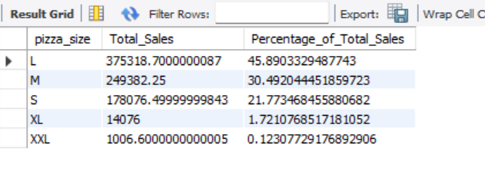

**F. Total Pizzas Sold by Pizza Category**

SELECT pizza_category, SUM(quantity) AS Total_Quantity_Sold

FROM pizza_sales

GROUP BY pizza_category

ORDER BY Total_Quantity_Sold DESC ***Output***

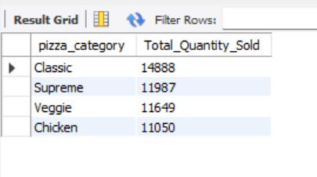

**G. Top 5 Pizzas by Revenue**

**SELECT pizza_name, SUM(total_price) AS Total_Revenue FROM pizza_sales**

**GROUP BY pizza_name**

**ORDER BY Total_Revenue DESC**

**LIMIT 5**

**H. Bottom 5 Pizzas by Revenue**

SELECT pizza_name, sum(total_price) as Total_Revenue from pizza_sales

GROUP BY pizza_name

ORDER BY Total_Revenue

LIMIT 5

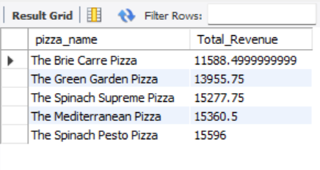

**I. Top 5 Pizzas by Quantity**

SELECT pizza_name, SUM(quantity) AS Total_Quantity FROM pizza_sales

GROUP BY pizza_name

ORDER BY Total_Quantity DESC

LIMIT 5

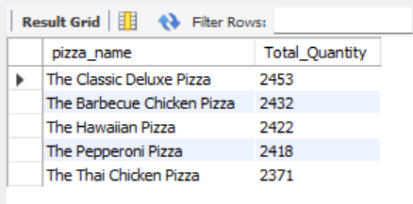

**J. Bottom 5 Pizzas by Quantity**

SELECT pizza_name, SUM(quantity) AS Total_Quantity FROM pizza_sales

GROUP BY pizza_name

ORDER BY Total_Quantity

LIMIT 5

**K. Top 5 Pizzas by Total Orders**

SELECT pizza_name, COUNT(DISTINCT order_id) AS Total_Orders FROM pizza_sales

GROUP BY pizza_name

ORDER BY Total_Orders DESC

LIMIT 5

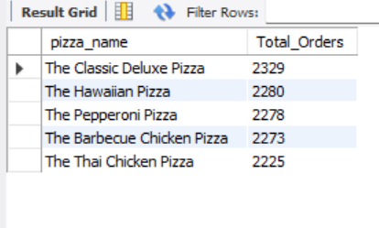

**L. Bottom 5 Pizzas by Total Orders**

SELECT pizza_name, COUNT(DISTINCT order_id) AS Total_Orders FROM pizza_sales

GROUP BY pizza_name

ORDER BY Total_Orders

LIMIT 5

